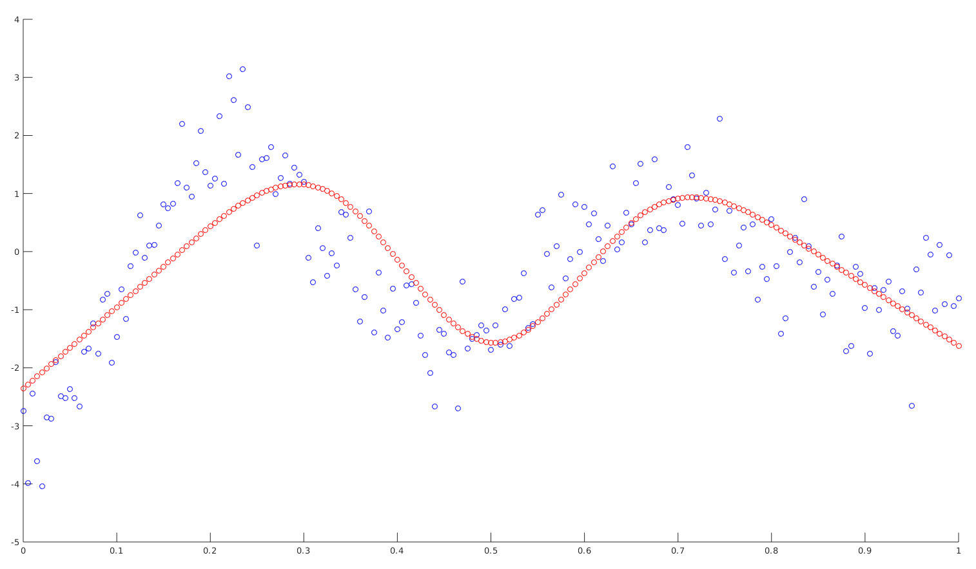
Question 1. When I run my code I get the following graph with lambda = 0 (No Omega matrix). My knots are the following: 0.165, 0.335, 0.500, 0.665, 0.835. Is this reasonable? The blue points correspond to the training data and the red points correspond to the predictor using the x value of the training points to generate. I understand that there are only 5 knot points, but it still seems odd to me. The theta vector is the following (N1 to N5 weights): -2.358, 14.009, -188.493, 485.851, -449.928.

Question 2. When I use lambda = 1, it surpresses the curve too much. It makes me think that I implemented the Omega matrix incorrectly. What I am doing is using symbolic operations within Matlab to get my values. I define the second derivative d_{i} functions using symbolic variable t, construct the second derivative N functions, and then use integrate(N1’’ * N2’’, [0, 1]) to get Ω₁₂ for example. I defined the second derivative di functions as follows: . My understanding is that we are integrating with respect to t which goes from 0 to 1 in our dataset therefore I can integrate the N’’ functions symbolically but maybe I’m misunderstanding the material. My graph looks like this (next page). I also included my omega matrix.
